MX00.1: Create the Attribute
- Give it a name and a heading. I’ve never seen where Column Heading shows. I use it as a ‘note’ field.
- Define the element type. Finance had created these over the years, but it’s MX00.2
- Click ADD.
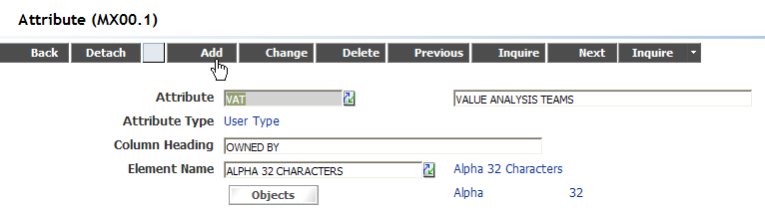
MX00.3: Tie to Object(s)
- From MX00.1, click Object.
- FC: A(Add) and use Select Value to tie the item to whichever tables are required:
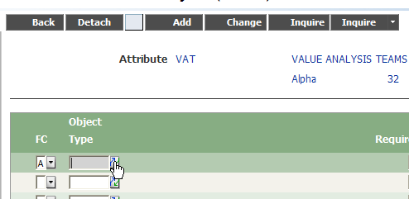
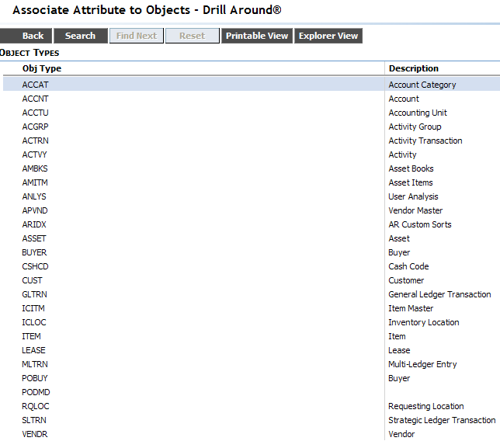
These tables are set by the software. Creating an attribute for something else would require customization work and would not be supported.
Selecting the table will take you back to MX00.3 where you can add more objects or make them required or just click add:
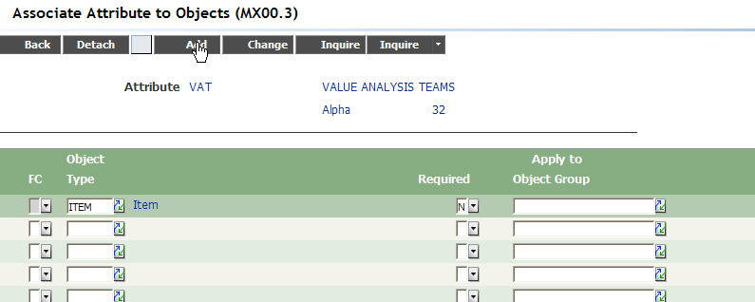
The object groups (MX00.4) are not used by MHS procurement but if you have multiple companies or have items tied to Finance activities management, you may want to look at those as well.

Once you’re done, click BACK and return to MX00.1 and populate values.
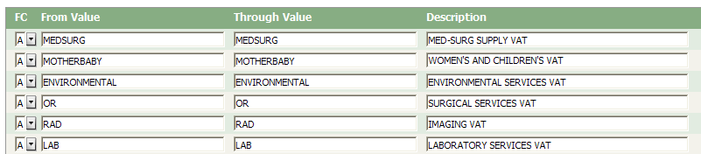
For text elements (assigned above), the from and through values are the same. Numeric elements can have ranges.
Click CHANGE.

IC56: Ties Attribute Values to the item.
You can go item by item and assign a value:
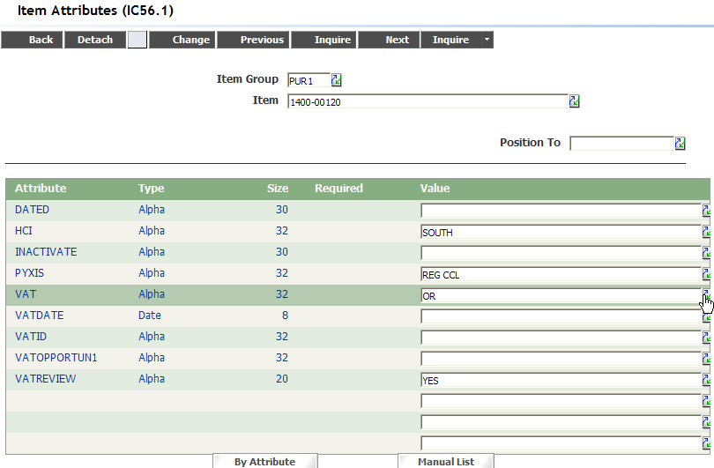
To Upload:
F2: Item Group
F3: Item
F6: pt-imv-matrix-cat (the attribute – in my example: VAT)
F15:0 imx-mx-value1 (the value – in my example: OR)
Upload as Change Only.
This screen is good to see all the values for all the attributes.

IC56.2: Lists items by Attribute
You put in the attribute and it lists all the item master so you can populate “all at once” – you can also upload to this screen.

I’m including a screenshot of the RQ01 version as it’s populated:
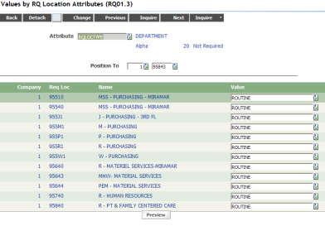
Our process flow for req approval is branched by req location type (routine, high dollar, capital, oversight) so this screen is easier to see which ones are blank.

