How to Key in A No Charge Special.
Key in the item – the flag is no longer on the specials screen so you have to key in a cost at first.
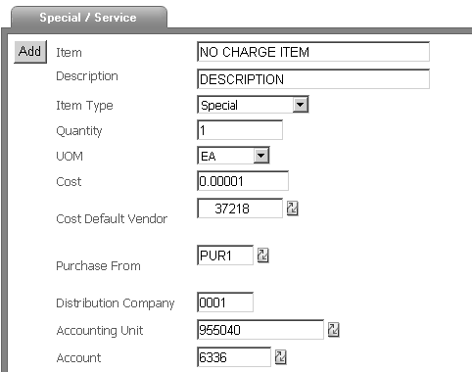
You do not want to leave it like this however because it requires an invoice or will appear on your budget as a discrepancy.
Add the item to your cart then click on the link to make changes
On the Basic (first) tab, delete the cost and change the Cost Option flag to No Charge.
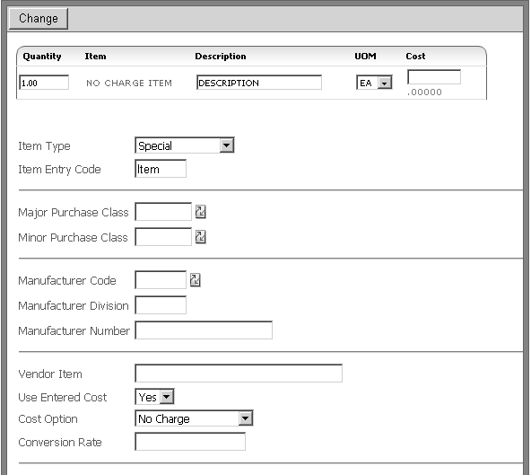
When you click Change the Cost field will populate “No Charge” on the tab:
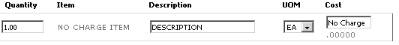
and 0.00000 on the cart. Save changes and comment and check out as normal.

