STEPS How to set up the standard PO115 jobs
- Go to PO15 and create the job name to match the desired standard job.
- Main Tab: All Standard Jobs
- Procurement Group: POGP
- Update: Y (Update Mode)
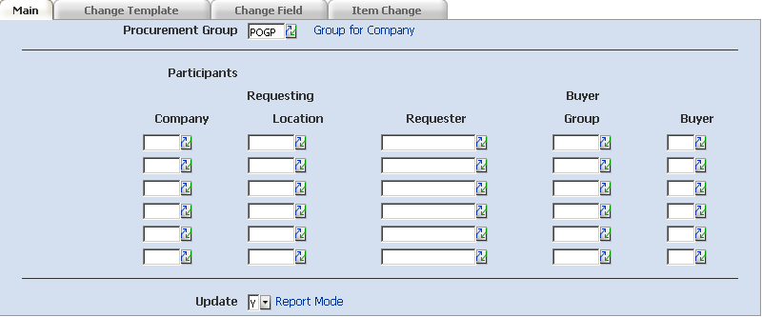
- Participants: Optionally, you can filter by departments. (Change previous option to No)
- Change Template Tab: All Standard Jobs
- All Templates: Y (Yes)
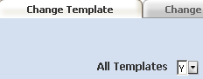
- Template Ref: Optionally, you can specify up to 6 templates to update
- Change Field Tab:
- Optional: Quantity: sets default template quantity
- Standard Job “UOM”:
Item: Lawson Number
UOM: New Buy UOM
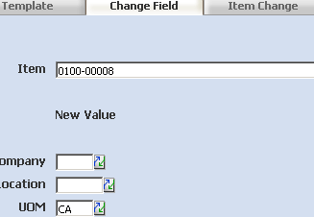
- For all other standard jobs, this Tab is blank.
- All other fields are restricted at MHS. See Lawson Knowledge Base for further information.
- Item Change Tab:
- Standard Job “UOM”: leave blank
- Standard Job “Replace”
- Replace Item A with Item B: Item A: Old Lawson number
- Replace Item A with Item B: Item B: New Lawson number
- Standard Job “ADD”:
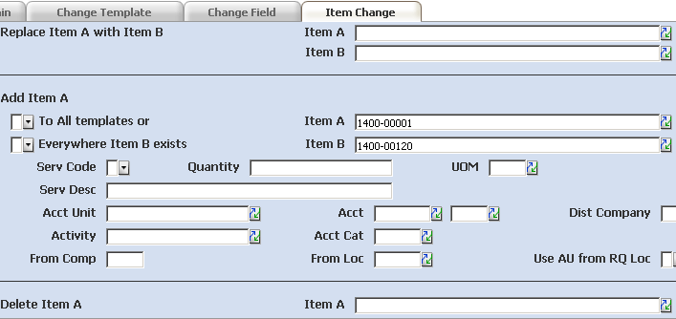
- Add item A Everywhere Item B exists: Y
- Item A: New Lawson number
- Item B: Existing Lawson number
- For Standard Job “DELETE”
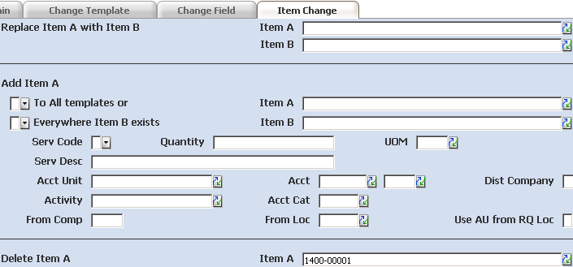
- Delete Item A Item A = Lawson number
- The other options available on this Tab are not utilized by MHS.
- Click Add and verify the status bar reads, “Add Complete – Continue”.

