**BN15**

**MAIN** TAB

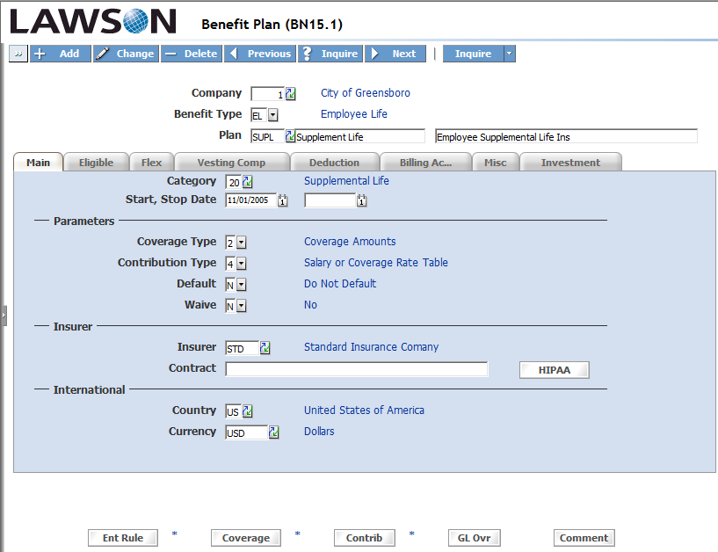

**ELIGIBLE** TAB

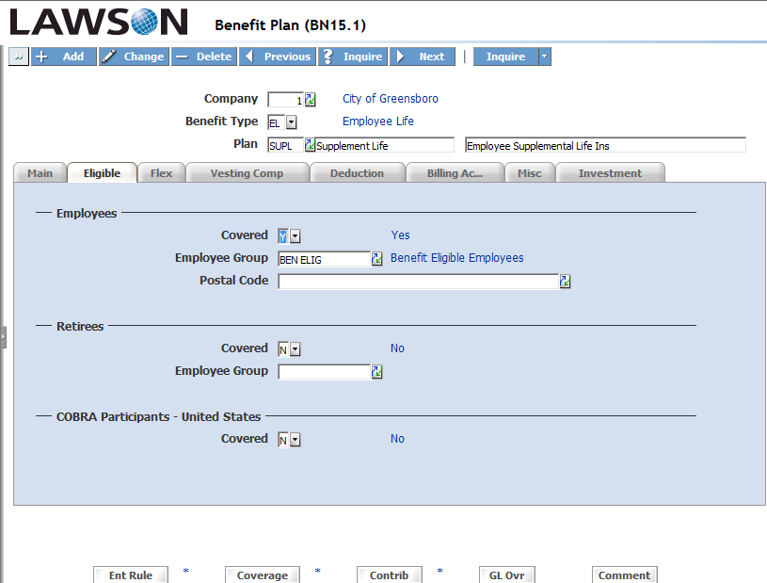

**DEDUCTION** TAB

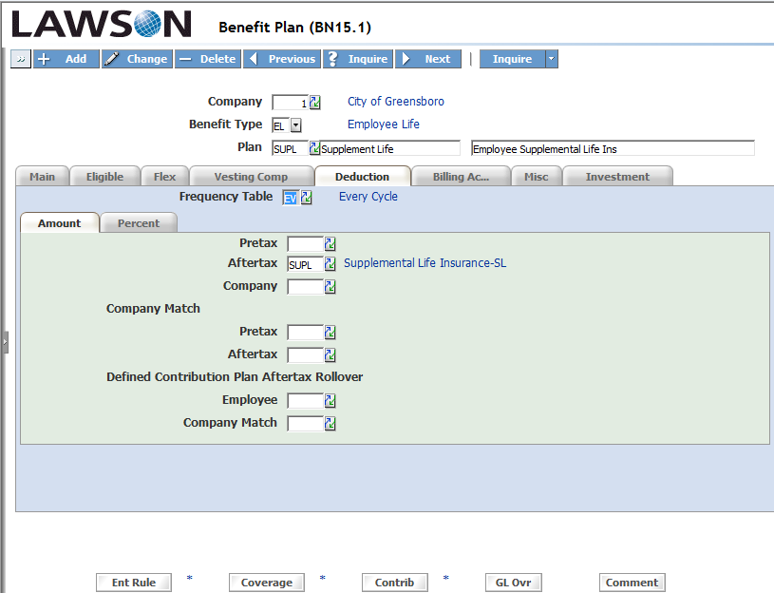

**PR05**

**DEDUCTION** TAB

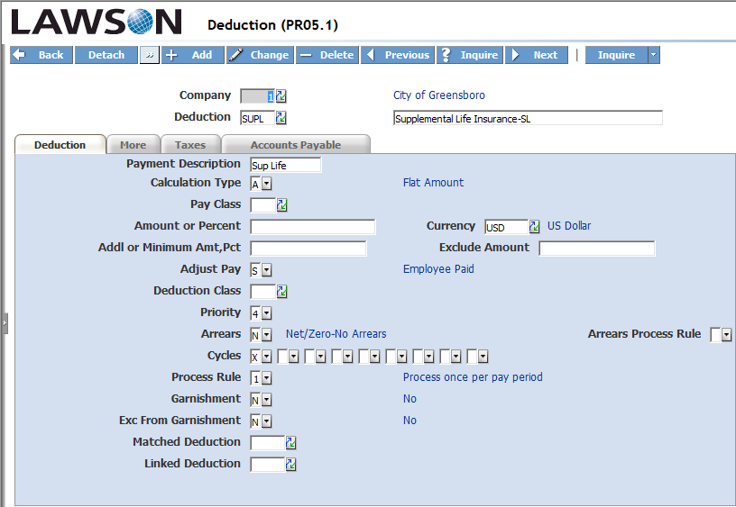

**MORE** TAB

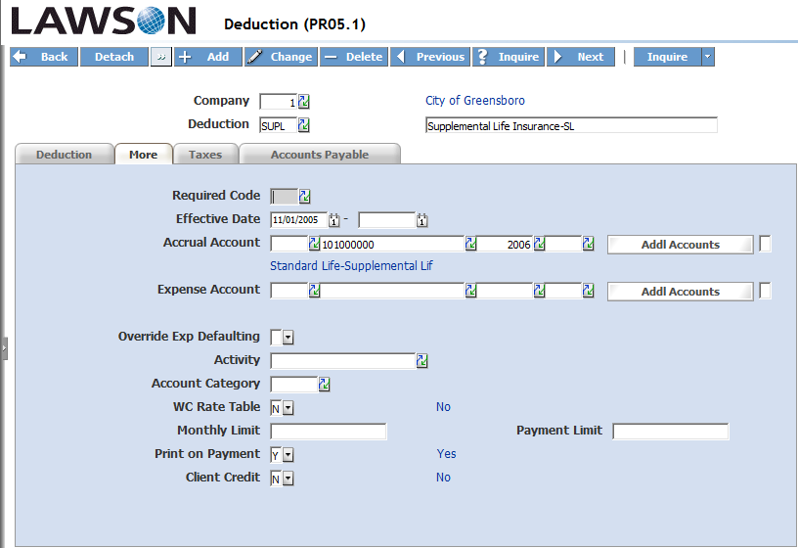

**TAXES** TAB

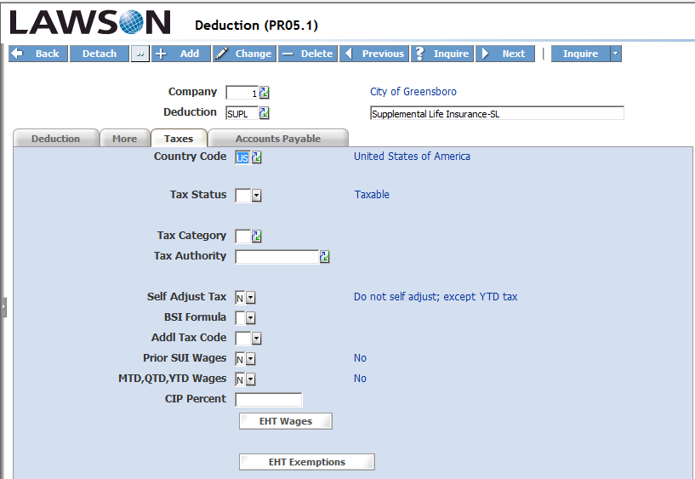

**ACCOUNTS PAYABLE** TAB

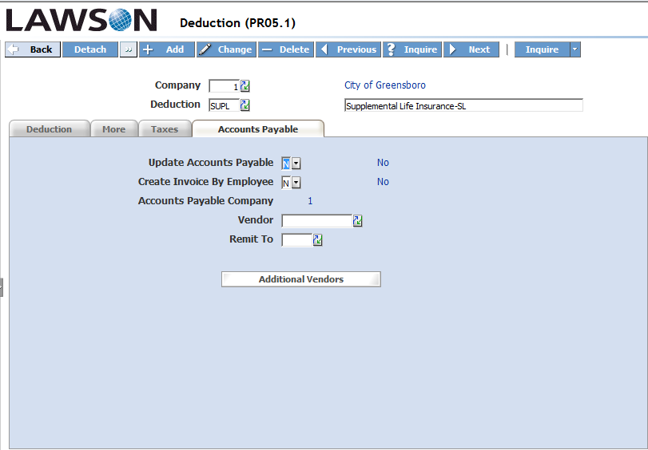

**BN15**

**\*ENTRY RULE** TAB

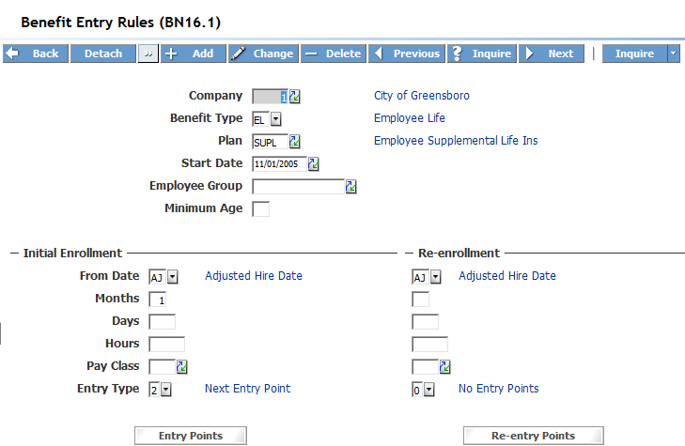

**ENTRY POINTS** TAB

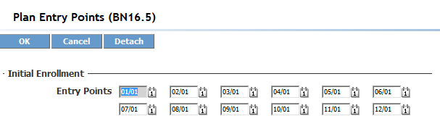

**\*COVERAGE** TAB

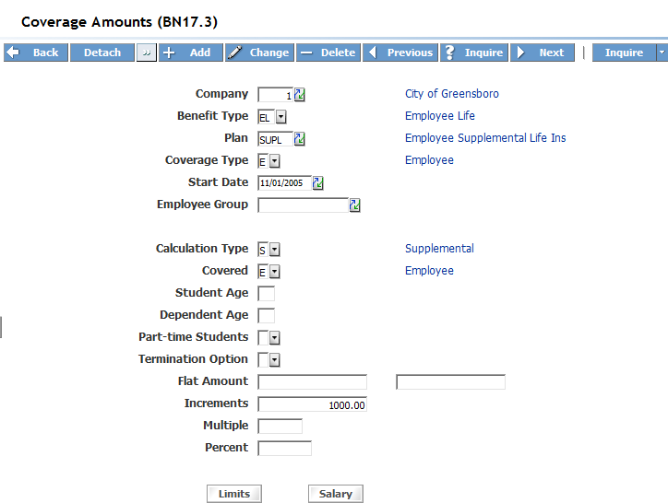

**LIMITS** TAB

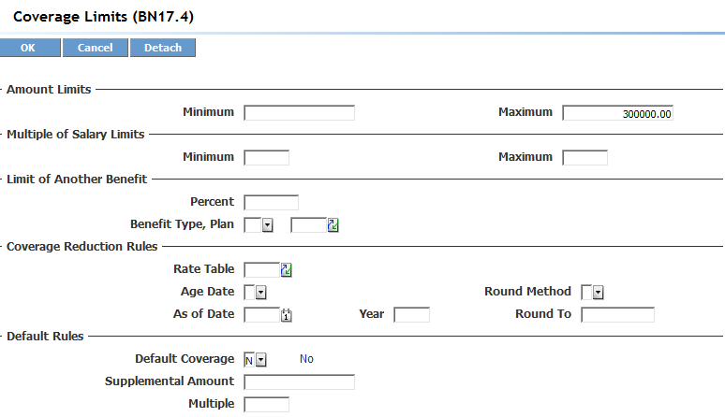

**\*CONTRIB** TAB

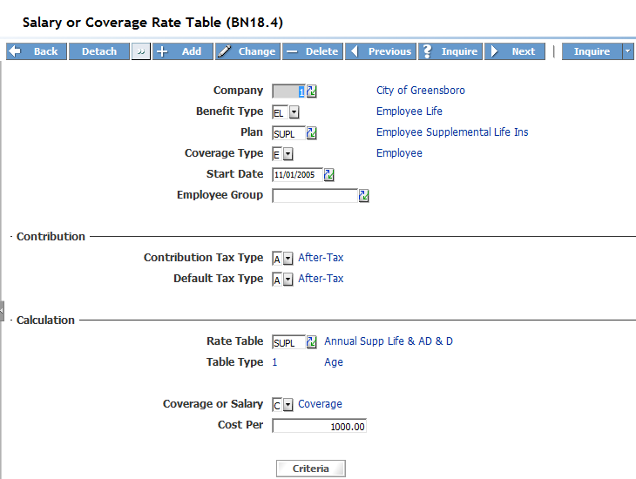

**\*CRITERIA** TAB

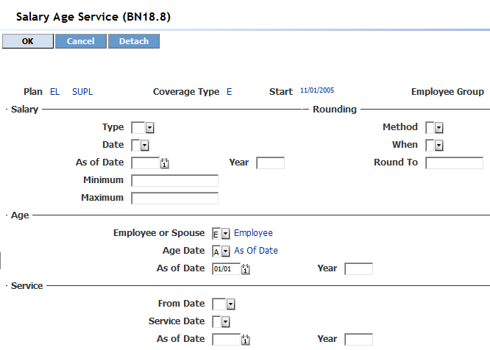

**RATE TABLE** FIELD <<AGE RATE TABLE>>

